RBX Abstract for DDW 2022

MICROBIOME AND BILE ACID RESTORATION WAS CONSISTENT ACROSS THREE CLINICAL TRIALS OF RBX2660 FOR RECURRENT CLOSTRIDIOIDES DIFFICILE INFECTION: A COMBINED ANALYSIS
Ken Blount PhD¹, Heidi Hau PhD¹, Romeo Papazyan PhD², Bryan Fuchs PhD², Bill Shannon PhD MBA³, Carlos Gonzalez MS³
¹ Rebiotix Inc, Roseville, MN, USA, A Ferring Company; ² Ferring Research Institute, San Diego, CA, USA ³ BioRankings, LLC, St. Louis, MO, USA

BACKGROUND
Recurrent Clostridioides difficile infections (rCDI) are an urgent public health threat associated with microbiota disruption. RBX2660 is a microbiota-based investigational live biotherapeutic that has been evaluated in >600 clinical trial participants for reducing recurrence of rCDI. Here we report the combined microbiome and metabolomic analysis of participants in three trials of RBX2660, including correlation of treatment received and clinical response with restoration of 1) microbiome composition and diversity, 2) a recently published Microbiome Health Index™ (MHI-A) biomarker of post-antibiotic dysbiosis and restoration, and 3) bile acid compositions.
METHODS
Included in this analysis were samples from RBX2660- or placebo-treated participants in the randomized, double-blind, placebo-controlled PUNCH CD2 (n=153) and PUNCH CD3 (n=887) trials and from the open label PUNCH OLS (n=653). Clinical response was defined as the absence of CDI recurrence (presence of CDI diarrhea and a positive C difficile toxin test) at eight weeks after treatment. Participants voluntarily submitted stool samples prior to blinded study treatment (BL), 1, 4 and 8 weeks and up to 24 months after study treatment. Samples were extracted and sequenced using shallow shotgun methods. Operational taxonomic unit (OTU) data were used to calculate relative taxonomic abundance, alpha diversity, and the MHI-A—a microbiome biomarker of post-antibiotic dysbiosis and restoration. A liquid chromatography mass spectrometry method was used to quantify 33 bile acids for samples from PUNCH CD2 and CD3.
RESULTS
Relative to baseline, microbiome diversity (Mann-Whitney) and microbiome composition (Generalized Wald Test) shifted significantly in treatment responders for all three trials, with greater shifts among RBX2660-treated than placebo-treated responders—Bacteroidia and Clostridia were increased and Gammaproteobacteria and Bacilli decreased after treatment (Fig 1A). In all three trials, MHI-A was restored from dysbiotic to healthy levels concurrent with clinical response (Fig 1B), less so among placebo responders. Finally, in PUNCH CD2 and CD3, bile acid compositions were restored from primary predominance before to secondary bile acid predominance after treatment (Fig 1C)—a composition more resistant to C. difficile colonization and infection.
CONCLUSION
Collectively, these results indicate a totality of evidence that RBX2660 restored microbiome and bile acid compositions concurrent with clinical response, and the restorative changes are characteristic of shifts from a post-antibiotic dysbiosis state to a healthier state.

Figure 1. Microbiome (A), MHI-A (B), and bile acid composition (C) changes among PUNCH CD2 (2), PUNCH OL (OL), PUNCH CD3 (3). Included are prior to investigational treatment (BL), one, four, and eight weeks after investigational treatment (1W, 4W, 8W).

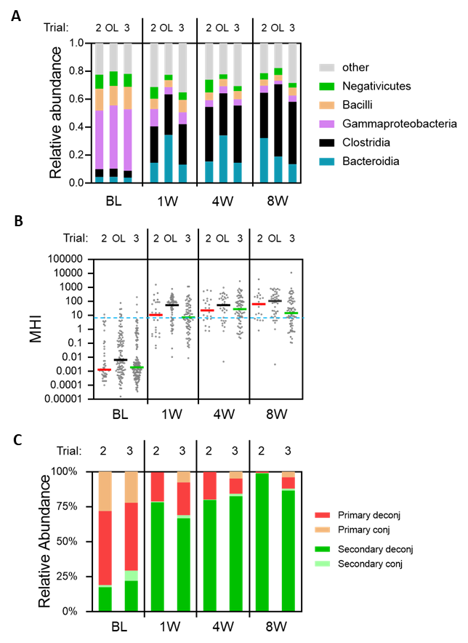

Current Character Count of 2900 allowed (including spaces): 2889
Up to 2 figures allowed (but figure legend is included in character count)

