RBX Abstract for IDWeek 2020 – DUE JUNE 18, 2020 4p CDT - 1950 characters (spaces not included) and <4 figures

Rapid Restoration of Bile Acid Compositions After Treatment with Investigational Microbiota-Based Therapeutic RBX2660 For Recurrent Clostrioides difficile Infection
Nicky Ferdyan¹, Romeo Papazyan¹, Dana Walsh², Sarah Klein², Steve Qi¹, Ken Blount², Karthik Srinivasan¹, Bryan C. Fuchs¹
¹ Ferring Research Institute, San Diego, CA, USA; ² Rebiotix Inc, Roseville, MN, USA
BACKGROUND Recurrent Clostrioides difficile infection (rCDI) is a public health threat associated with intestinal microbiome disruption (dysbiosis), which is postulated to increase CDI recurrence risk via disruption of bile acid(BA)-mediated resistance to C. difficile colonization. RBX2660 is an investigational microbiota-based therapeutic in clinical development for reducing rCDI recurrence. Herein, we assessed BA composition among participants in a Phase 2 trial of RBX2660 for rCDI.
METHODS In a double-blinded trial (PUNCH CD2), rCDI participants were randomized to receive RBX2660 or placebo. Primary efficacy was defined as absence of CDI recurrence at 8 weeks after the last study treatment. Participants were asked to provide stool samples before (baseline) and up to 24 months after treatment. A liquid chromatography tandem mass spectrometry method was developed to extract and quantify 36 BAs from a total of 167 participant stool samples from 47 participants. Participant-matched samples at baseline and 1, 4, and 8 weeks were compared with a linear mixed effects model.
RESULTS Primary BAs predominated at baseline but were significantly reduced (p<.02) as early as 1 week after treatment and remained so to 24 months. Concurrently, secondary BAs, most notably deoxycholic acid (DCA) and lithocholic acid (LCA), were significantly increased (p<.01) after treatment and remained so throughout. Moreover, increases in DCA and LCA were associated with treatment response (p=.05 and p<.01, respectively), recognizing the limited sample size of treatment failures. Observed BA changes coincided with changes in taxonomic compositions—a shift from Gammaproteobacteria and Bacilli predominance before treatment to Clostridia and Bacteroidia predominance after treatment.
CONCLUSIONS In a trial of RBX2660 for rCDI, participant BA compositions significantly changed from before to after treatment, remained so for at least two years, and correlated with treatment outcome. The resulting predominance of secondary BAs coincided with microbiome compositional changes. Because secondary BA are thought to repress C. difficile colonization, these changes may partly explain how RBX2660 reduced CDI recurrence. Continued evaluation of RBX2660 for rCDI is underway.

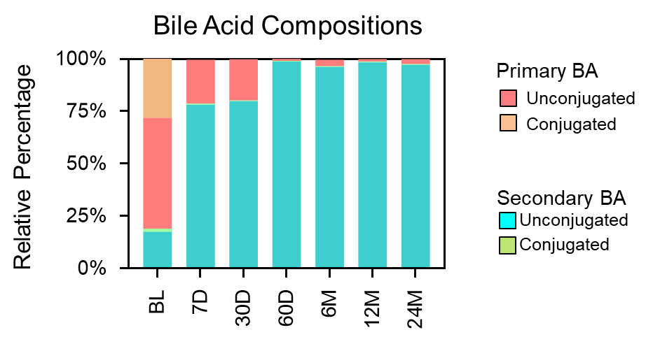
Figure 1: BA restoration of successfully-treated participants

